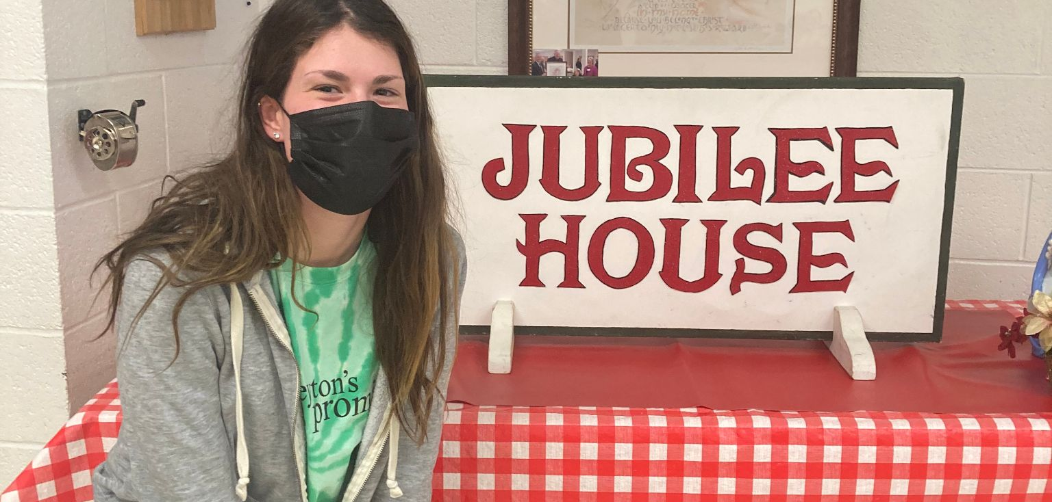
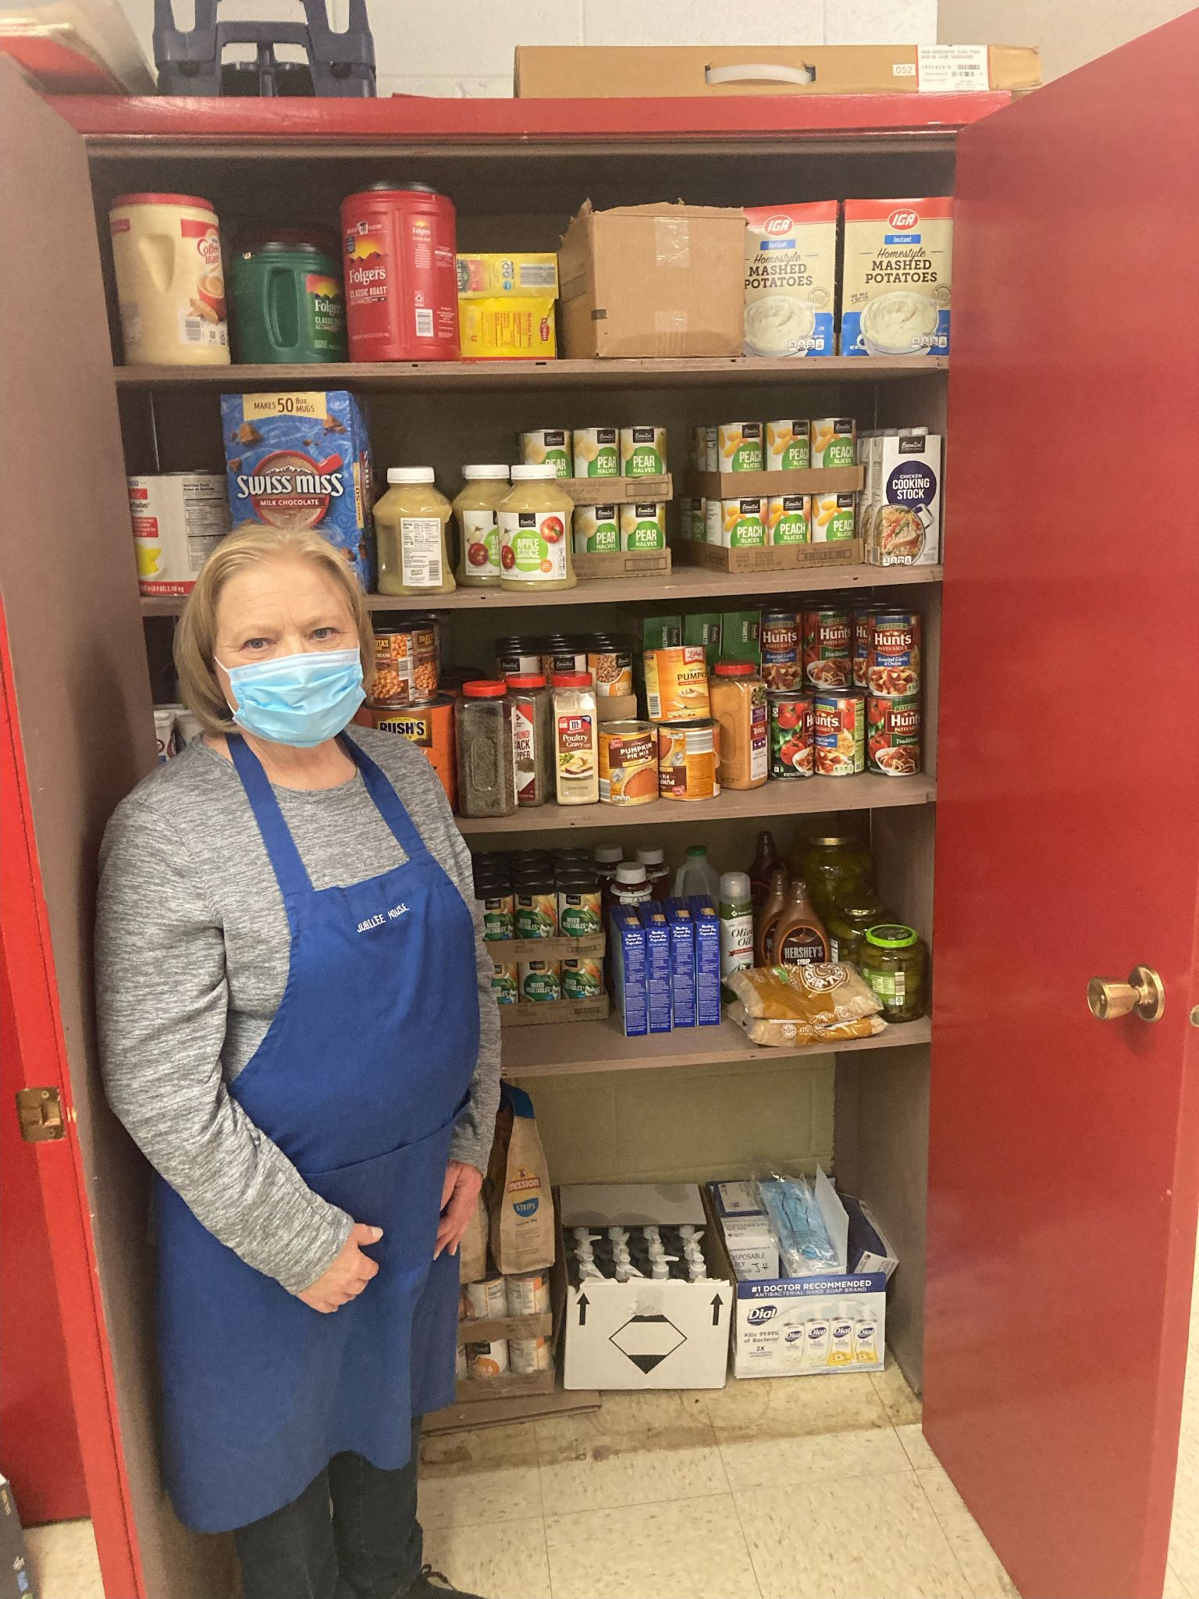
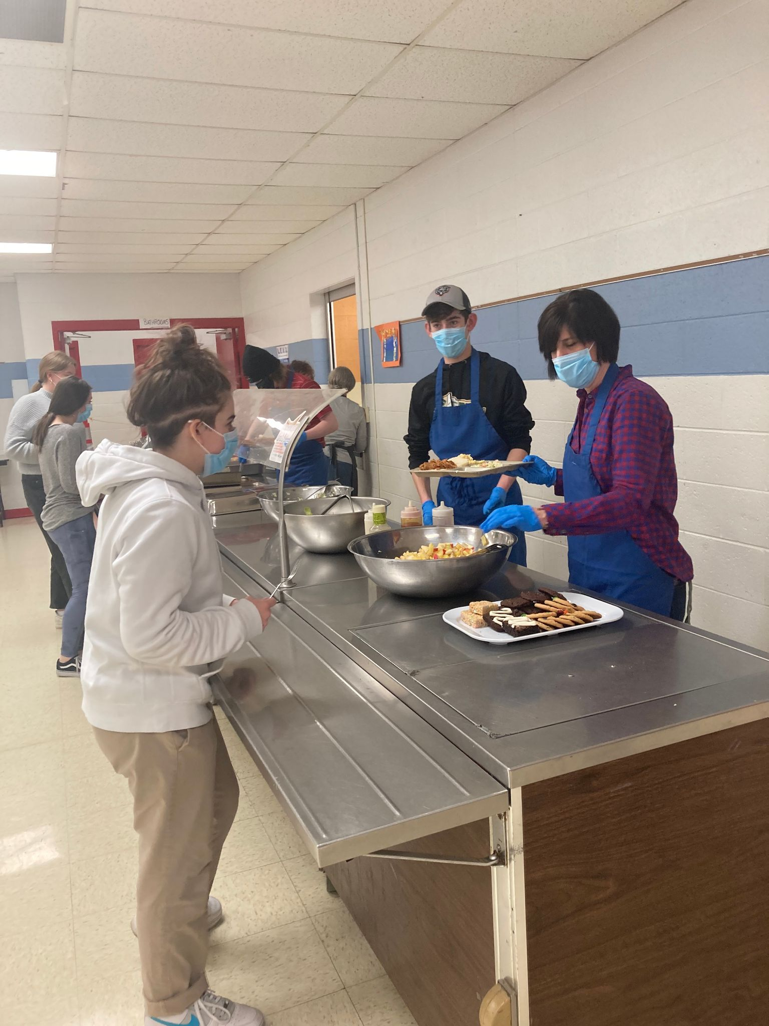

Who: Jubilee House is a Catholic Worker House non profit at the St. Matthew School Cafeteria, who welcomes anyone no matter what their station is in life. Jubilee House is managed by the Core Group and serves food through a group of dedicated volunteers who help staff Jubilee House. They welcome students, groups, and area businesses to serve hot meals at Jubilee House on Thursday’s. Jubilee House opened serving its first meal on July 13, 2000 with the name chosen due to Pope John Paul II declaring a Jubilee Year in 2000.

What: Jubilee House offers a free community meal and hospitality every Thursday night, with the exception of Holy Thursday and Thanksgiving, to anyone and everyone with doors opening at 4:00pm and serving food from 4:30pm-6:00pm. The meals are donated, prepared, and served by various volunteer groups, including confirmation classes, businesses, nursing homes, families, Scouts, Churches, Men’s Club, Secular Franciscans, etc. Besides the meals, Jubilee House gives exceptional hospitality and a friendly environment to gather with friends and talk to others for a sense of community and togetherness.

Where: 221 South 28th Avenue Wausau, WI 54401. If you are taking public transportation, you can get off at 28th Ave in Wausau to get to St. Matthew School Cafeteria.

When: Community meal served every Thursday from 4:30 – 6:00 PM. Doors open at 4:00 PM. Closed on Holy Thursday, Thanksgiving, and any time a holiday falls on Thursday. Closes for inclement weather whenever the Wausau Schools are closed.

Additional Information: Does not function as a food pantry, and they do not provide carry out meals, shelter, or clothing.


For more information check out their website: https://www.jubileehousewausau.org/ or for general information contact Core Group Members: Judy Tapper at 715-848-6120, Judy Pederson at 715-675-9215, or Faye Brezinski at 715-845-3302. If you would like to volunteer and serve/prepare meals please contact Charlotte Santana at 715-842-4582.

